Wigii – Reference manual


→ How to manage the Config
> This document describes the syntax of the .xml configuration files

A Config file per Tab

In the Wigii system a moduleName corresponds to the tab name in which the configuration applies
(i.e. Contacts / Files / Events / Inventory / News / Programs / Tasks / Transfer / Help)

There is a dictionary which contains the translation of the different tag names like the moduleName for example. The Tab names are actually the result of a translation of the stored tags
> moduleName translation example :
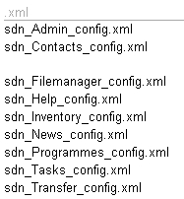
Config File
Dictionary

Contacts
Calendar
Filemanager
Help
Inventory
News
Programmes
Tasks
Transfer
KEY EN- FR

Contacts :ContactsContacts
Calendar :CalendarCalendrier
Filemanager :FilesFichiers
Help :HelpAide
Inventory :InventoryInventaire
News :NewsNews
Programmes :ProgramsProgrammes
Tasks :TasksTâches
Transfer :Transfer Transfer

moduleName
sdn_Calendar_config.xml

→ The translation is then used for the Tab names
English :

Français :

This implies that the moduleName of the files tab is Filemanager
Note : The dictionary is in the lang folder. The namespace creator of a client can overwrite some entries in the dico_Clientname.txt in the client config folder

XML config File

> What is XML ?
> XML stands for EXtensible Markup Language
> XML is a markup language similar to HTML
> XML was designed to carry data and not to display data (HTML displays data)
> XML tags are not predefined
> XML is designed to be self-descriptive
> XML is a W3C Recommendation

> XML does NOT do anything
XML was designed to transport and store data
The following example is a note to Marc from Jim, stored as XML :
<note>
<to>Marc</to>
<from>Jim</from>
<heading>Hello</heading>
<body>Hi, how are you doing ?</body>
</note>
The note above has a sender, a receiver, a heading and a message
But this XML document does NOT do anything. It is just information contained in
tags. A software must still be used to be able to send, receive and display it

> XML Tags
The tags in the example above (such as < to > and < from >) are not defined in any XML standard. These tags are "invented" and created by the author of the XML document
That is because the XML language has no predefined tags. XML allows the author to define his own tags and his own document structure
A Tag is a label assigned to identify data in the Config
Elements have three components: a pair of element tags ( a "start tag" and "end tag" ), attributes within the start tag and content between the start and end tags. The element is everything between and including the tags. Each tag is enclosed in angle brackets “<” & “>”

The general form is therefore :
content

The element name is also the name of the tag. Note that the end tag's name is preceded by a slash character, "/".

Wigii Config File Structure

When creating an .xml file you will use the following tags :

Start with :
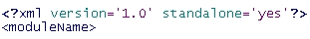
>

Between the <modulename> tag insert the parameters, fields and different activities

> <parameters The different parameters of the module />
> <fields> The information needed for an element </fields>
> <listView> How the information is viewed </listView>
> <selectSearchBar> How an element can be filtered </selectSearchBar>
> <feedbackOnElement> Feedback feature on element </feedbackOnElement>
> <feedbackOnSystem> General feedback feature </feedbackOnSystem>
> <notification> The notification email template </notification>
> <emailing> The emailing template </emailing>

And end with :
>
WARNING : Make sure you close all the tags, other wise the Wigii system will NOT work !

Parameters
IMPORTANT :
Theses are all the parameters that you should always have in a Config file
- This is the code structure
<parameters
FeedbackOnSystem_enable="1"
FeedbackOnElement_enable="1"
Notification_enable="1"
Notification_enableDynamicSubscription="1"
Notification_alwaysForceNotification="0"
Notification_enableMessage="1"
Notification_enableOnSharing="0"
Notification_enableMessageOnDelete="1"

ExcelExport_enableSysDate="1"
ExcelExport_enableId="1"

Element_enableLockedStatus="0"
Element_enableLockedStatusOnEdit="0"
Element_enableImportant1Status="0"
Element_enableImportant2Status="0"
Element_enableArchivedStatus="0"
Element_enableDeprecatedStatus="0"
Element_enableHiddenStatus="0"
Element_viewVersion="0"
Element_viewInfo="1"
Element_viewId="1"
Element_evaluator="CustomizedElementEvaluator"

Group_selectAllGroupsOnFirstLoad="0"
Group_IncludeChildrenGroupsOnSelect="1"
nbOfLevelToExpandOnInit="2"
Group_enableDynamicConfig="1"
Group_enablePortal="1"
Group_enableSubscription="1"
Group_enableXmlPublish="1"

elementTotalWidth="550"
elementLabelWidth="200"
sendEmailTotalWidth="550"
sendEmailLabelWidth="200"
sendFeedbackTotalWidth="500"
sendFeedbackLabelWidth="175"
shareMultipleElementTotalWidth="500"
shareMultipleElementLabelWidth="175"

/>

Configures if the system sends notification emails and when.
Define if the notifications can be edited/skiped before send.

Is date & id exported in the excel sheet

Enables the status menu of an element.

Enables the history information (creation date & user, last modify data & user) in the detail card.

Define how the group selector panel manages groups.

Enables some features on groups as: subscription or cover page.

Define the width of the forms (label and input) per activity. The main one is elementTotalWidth and elementLabelWidth.

- All the different parameters are set in this Tag
- You can set different values for a parameter in the brackets
Note : To find out all the possible values refer to the “Config Manual“

> XML Values
You can set different kind of values in the brackets
0 = inactive
1 = active
If the value is a width then you can enter any positive value
Note : The Width units are pixels
If attributes are not assigned, default values will be used

Fields
When you create a field you need to set a type (dataType) and then it’s attributes (attribut)

Structure :
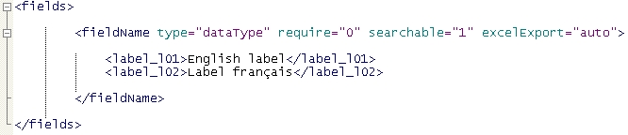

- Replace the fieldName by any name of your choice
- Set which dataType must be used for the field
- Then set the values of the different attributes
- repeat this for each field you want to have

> DataType
A data type is a data storage format that can contain a specific type or range of values. The data type defines what sort of information will be used
This is a list of the dataTypes
> Strings : The information will be text (single line)
> Blobs : The information will be text (multiple lines)
> Emails : The information will be an email address
> Attributs : A dropdown list
> multipleAttributs : Check boxes
> Files: An uploaded file
> Addresses: An address (state or country can be added)
> TimeRanges: The information will be a begining date and an ending date.
> Booleans: A single checkbox
> Dates: A single date (time can be added)
> Time: An hour
> Urls: A website url
> Varchars : A multilanguage single line text (one value per language)
> Texts: A multilanguage multiple line text (one value per language)
> Attributs
Here is the explanation of few useful attributes
> require :
If you set the value as “1” the field will be compulsory and it will then be marked with an asterisks “*”
> Excel Export :
In a tag’s attributes you can set if and how it will be exported to Excel with export option of the wigii system
Values you can set : auto / int / 0 / none
Note : With “int” you can set the width of the columns and with “0” you create a collapsed column
> funcExp :
The attribute funcExp allow to define a function to calculate the value of the field. Here is the funcExp grammar:
funcExp::=funcCall|eof
* funcCall::=funcName '(' funcArg? (',' funcArg)* ')'
* funcArg::=funcCall|fieldSelector|value
* funcName::=word
* fieldSelector::=fieldName(.subFieldName)?
* fieldName::=word
* subFieldName::=word
* value::=NULL|'"' word '"'
The function names are define in the CustomizedElementEvaluator class define in a php file in the Client folder. A user with namespace creator rights can edit this file. The basics functions are:
implode(glue, val1, val2, …), first(val1, val2, …), doOnNotNull(result, val1, val2, …), calculateBirthday(americanDate)
Example:

Set the characters in-between the merged text
Set the second part to be merged
Set the first part to be merged

Use this attribute to merge information from different fields together.

The name of the document and it’s extension will be merged together such as : Document.pdf
Be sure to use the single and not the double brackets for this attribute (the funcExp grammar requires double quotes for string value)
Note : The subfield type contains the “.” of the extension

> HtmlArea :
With this attribute you can enable a text area which is actually a HTML text editor plug-in. (Used for Additional information, feedback text etc)
Note : This attribute can only be used for Blobs and Texts dataTypes
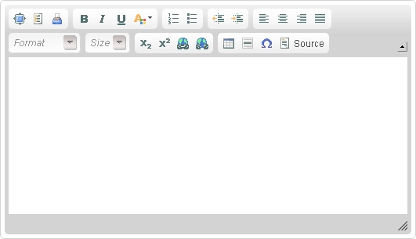
Note : This plug-in has the basic text editor options

To find out more read : How to use the HTML Text Editor.pdf

Note : For other Values / Attributs / DataType refer to the “Config Manual“

Listview

- This is the code structure of the list view
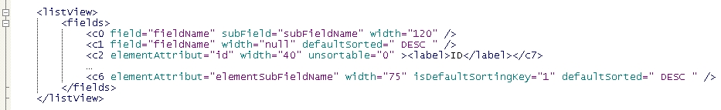
- To differentiate the different fields use a numbering system, in this case c0,c1,c2 etc

- In the listView you define the columns visible in the list of elements
- you can either:
  - display an existing field which you have previously set in the fields tag
  - in the case of a field containing subfields as for example an address you can define a subfield value to choose which subfield to display as city
  - display a system attribute of the element as: id, sys_date, sys_creationDate, state_locked, state_important1, etc.

- The attribute defaultSorted defines the order in which the elements are alphabetically sorted. The possible values are : ASC and DESC.
- The attribute isDefaultSortingKey defines which field is sorted in the list view by default
- When the field is a file you can display two special subfields :
> path : Adds a download button
> mime : Shows icon if there is a source document

- This is an example of list view in the files_manager for the E-library
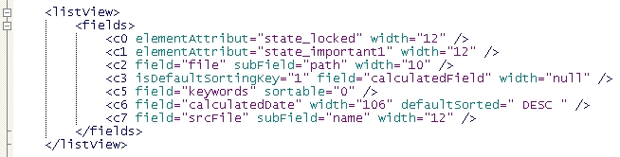

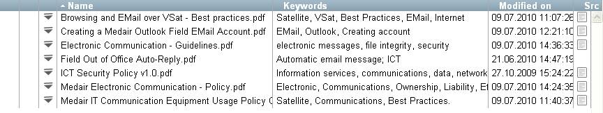
- The list then looks like this :

12 12 12VariableVariable 106 12
Select Search

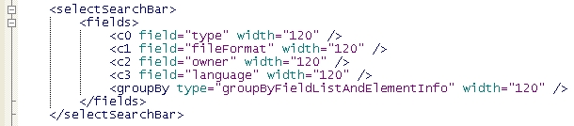
- This is an example code structure of the selectSearchBar

- The selectSearchBar defines the dropdown lists in the filters. The attribute field must refer to a tag which you have previously set in the fields tag.
- This example will create these filters to narrow down a research of an element
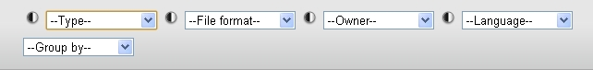

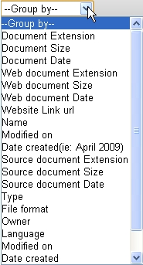

- The groupByFieldListAndElementInfo value in the type attribut activates a filter which enables you to group the elements by certain criteria

- For example if you group by :

This list view will be modified as such :

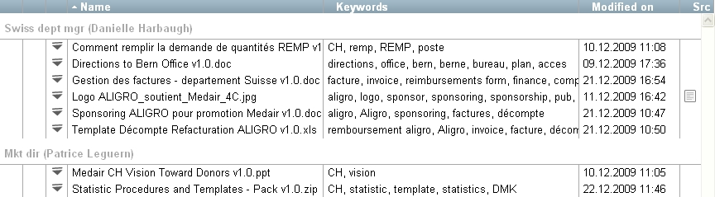

- The groupFilter value in the type attribut activates a filter which enables you to filter elements based on their membership of groups (folders)

<filterName type="groupFilter" width="120" >
<label_l01>Filter on group</label_l01>
<label_l02>Filtrer sur des groupes</label_l02>
<attribute groupLogExp="NOTINGR(id = 394)" >isNotField</attribute>
<attribute groupLogExp="INGR(id = 394)" >isField</attribute>
<attribute groupLogExp="INGR(id = 396)" >isAmbassador</attribute>
</filterName>

The syntax you can use is:

ING(groupLogExp) = returns element ids contained in the groups selected by the log exp

NOTING(groupLogExp) = returns element ids not contained in the groups selected by the log exp

INGR(groupLogExp) = returns element ids contained in the groups selected by the log exp or in any of its children groups

NOTINGR(groupLogExp) = returns element ids not contained in the groups selected by the log exp and not in any of its children groups

groupLogExp = logical expression with combination group fields, value as :
operators: <, >, <=, >=, =, !=, LIKE, NOTLIKE, IN, NOTIN
group fields: id, groupname, modulename, namespace, description…
In this example the first option filters on any items which is not in the group 394 or subgroups. To found the id of a group you can over the group with the mouse and read the id. You can search in the group list of the admin console for #394 and found the group with this id.

The aim of groups filters is to be able to do a selection within the current group of items belonging (or not belonging) to other groups.
Example:
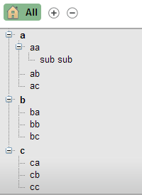
With this group structure we could define a groupFilter option as:

groupLogExp='INGR(groupname IN ("aa", "ba", "ca"))'

If you select all and then apply the filter above you will be able to take all the items which are in aa, or in sub sub, or in ba or in ca and exclude all the other items.

It is preferable to work with id's like this even after renaming the groups the filter still works.
Shown below are simplified examples of the File_Manager & the Contacts Config

> Contacts config : Defines the basic fields for the contacts information form (first name, last name, phone number, email, address and gender), how the contact is shown in the list view and by which criteria it may be searched by

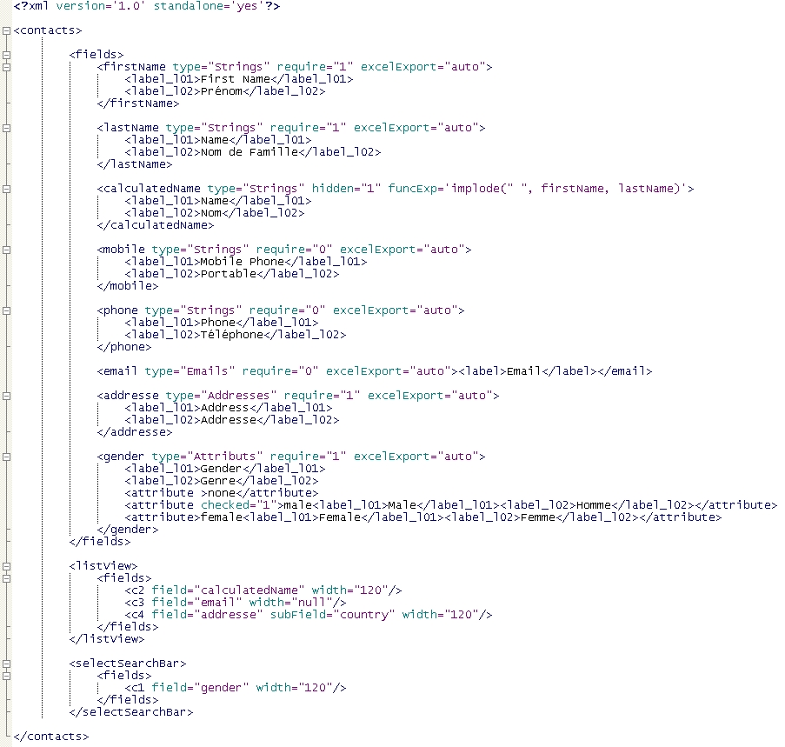
1
2

3

4

5

Note in red:
- the first name is required, this means this information must be filled
- the last name will be exported in excel and the column in excel will be auto sized
- the calculatedName field is hidden. This means this field is not showed neither in detail neither in the form. But it can be used in the listView. This field is calculated based on the value of the first name and last name. This allow to display in the listView only one column with the full name
- the gender is by default set to Male when you create a new contact. The checked=1 is to make by default one specific value
- In the listView we display only the country field of the address
- This is the Create a new contact window corresponding to the config above
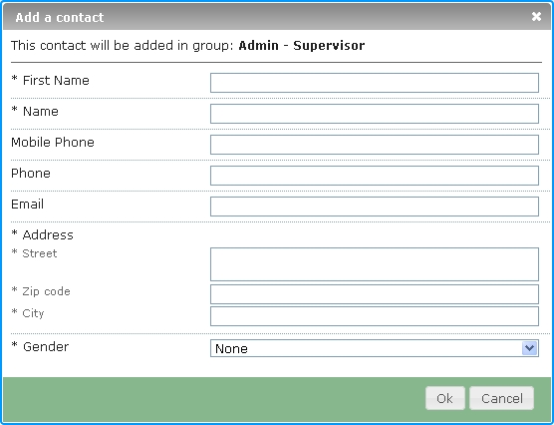
Male

- In the Config the listView is defined to show the calculatedName, email and addresse of the contact. This is how the Contact appears in the list view
Labels set in the contacts config
120
120
Variable

> Filemanager config : Defines the basic fields for the documents information form (Document name, keywords, version and document format), how the document is shown in the list view and by which criteria it may be searched by
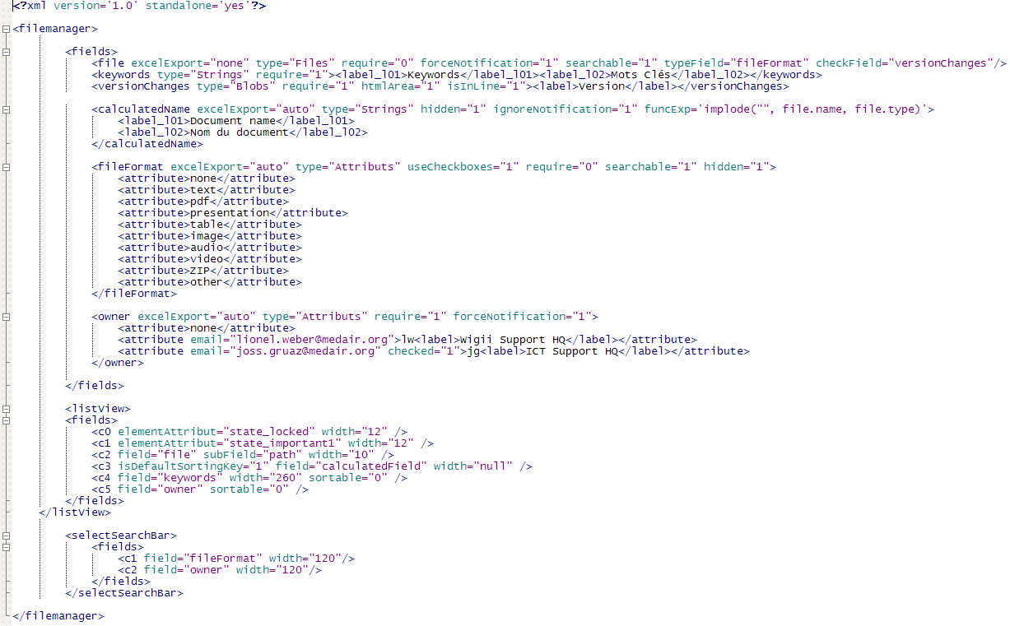
1
2
3
4

5

6

Note in red:
- This configuration is usefull only if the parameter Notification_alwaysForceNotification = 0. In this case the forceNotification = 1 define that this field will produce a notification if changed. If change are made only to field which are not forceNotification=1 then no notification will be sent.
- typeField is to refer to an other existing field and update the targeted field with the format of the file. In this case when a file is uploaded in the field file the field fileFormat is updated depending on the extension of the file. The user can then filter on fileFormat to find all the powerpoints, all the ZIP, etc. The field fileFormat have an attribute hidden=1 because it make no sense to display it in the form (the system will overwrite the user option with the corresponding option).
Note: a field refered in typeField must be a type=Attributs and have this exact list.
- checkField refers to an existing field which the content will be concatenated with check-out/check-in messages.
Note: a field refered in checkField must be a type=Blobs
- ignoreNotification will prevent the field to be displayed in the notification email. In this example the calculatedName is usefull only for the list view to display the file name with the extension. The calculatedName has redundant information by definition, so it make no sense to display it in the notification email.
Note: ignoreNotification is not the reverse of forceNotification. ignoreNotification only hide the field in the notification email it dose not influence the decision of the need to send a notification or not.
- useCheckboxes is an attribute available only for field with a type=MultipleAttributs. This attribute displays the options with checkboxes. The attribute isInLine=1 and useMultipleColumn=2 can be added to display the checkboxes in the full width in two columns.
- An email attribute is added to a specific option of the drop down list. This email attribute will be used to send notification. In this case any document added with the option ICT support HQ as owner will send a notification to joss.gruaz@medair.org.
Note: This email can also be used to send a feedback (see the feedback chapter for more detail).

- This is the add a document window corresponding to the config above
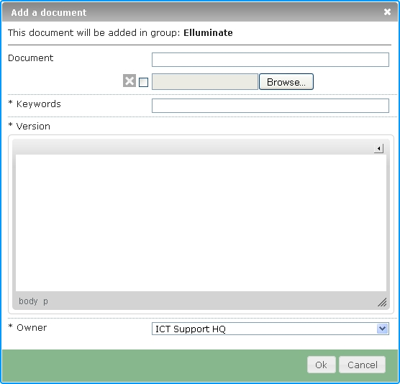

- In the Config the listView is defined to show the calculatedName, keywords and owner of the file. This is how the document appears in the list view
Labels set in the contacts config
ICT Support HQ

Feedback

IMPORTANT
When you create a feedback tag make sure that the parameter is active in the parameter tag such as :
> FeedbackOnElement_enable = “1”
> FeedbackOnSystem_enable = “1”

- This is the default code structure of the feedback form for an element
Note : In this tag feedback_from, feedback_email and feedback_for are compulsory.
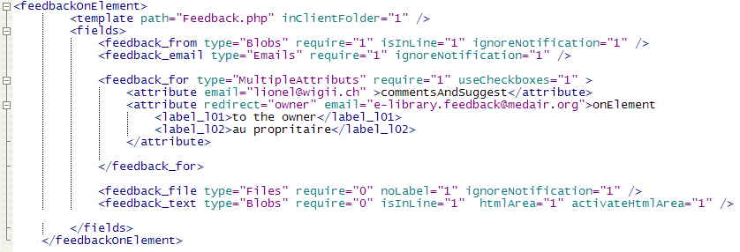

Note : The redirect attribute looks for the value of the content of a field
(In this example : owner) It needs to refer to a valid field + type (i.e. Emails, Attributs, MultipleAttributs with emails set)

- You can add other attributes in feedback_for
Note : You can add “##GroupEmailNotification##“ in the email attribute to send the feedback to all the emails subscribed to receive notification from the groups in which the document stand. You can define multiple emails by separating them with a comma or a space.

Note : If you want to add more fields in the feedback and you want to make some fields active only on one specific feedback_for option you can use a special syntax:
In this case all the following fields with a name beginning with feedback_special will be enabled only if the attach a document option is ticked. Else these fields are disabled.
This is result of the example (without the special example)
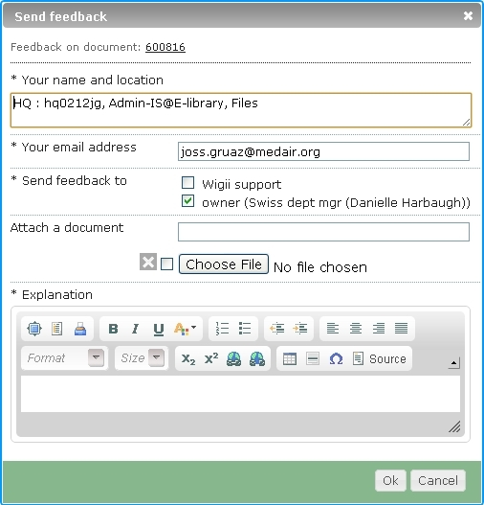
Feedback Options :
> feedback_for : Enables the user to select who the feedback will be sent to

> feedback_file : Enables the user to upload a file which will then be sent as an attachment with the feedback form

> feedback_text : Enables a text area where the user can write down his remarks / comments etc

- You can also create a feedback form concerning the system. Use the same syntax as and replace the FeedbackOnElement tag’s with the following :
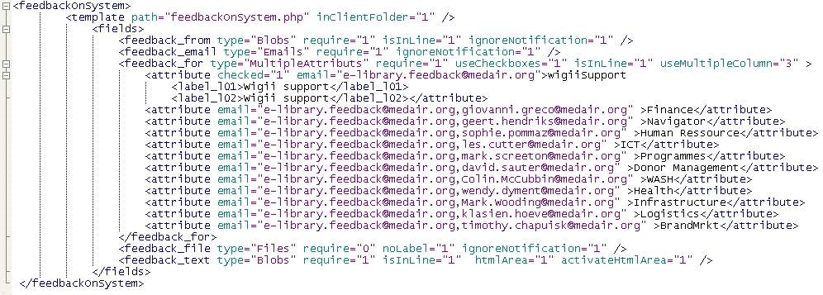

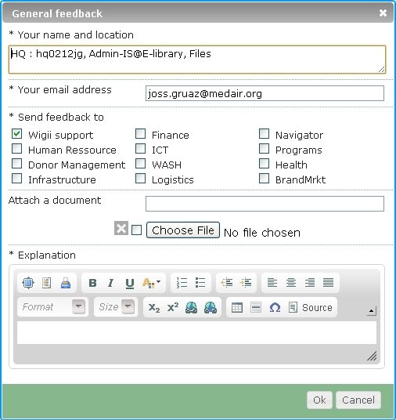

- You CANNOT use the “##GroupEmailNotification##“ attribute for the System feedback

- You CANNOT use redirect option because it is not linked to a document

Notification, emailing and feedback email templates

When the system sends an email for a notification, emailing, or a feedback it looks for a template. This template is a php file with code in it to prepare the email body.
To define which template to use for a specific action you need to add a template tag. The template tag has two attributes:
- path: the php filename
- inClientFolder 0/1 indicates if the file is in the client folder or in the general folder.
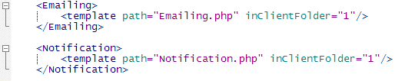
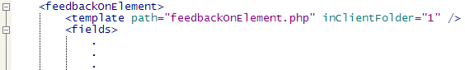

- The aim of the template is to be able to customize the emails for the corporate. We could also use different templates per group or per tab
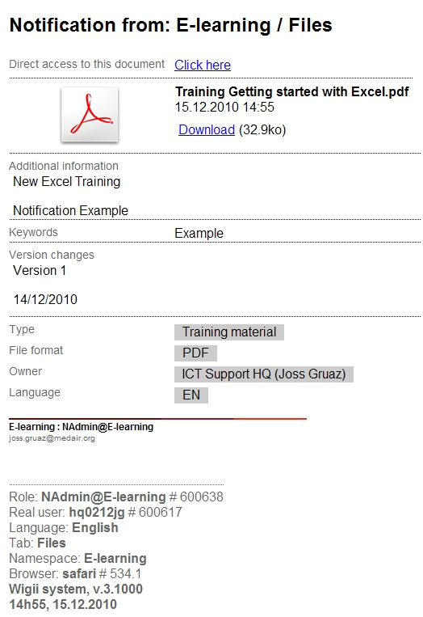
- This is notification example concerning the upload of a new document

- You can view all the documents information, who uploaded it and when

- you can also download the document by clicking on the download link

Because the template is defined in the configuration you could define a different template per module, per namespace, etc. Only namespace creators can change those templates. Refer to the technical document "Wigii Email-Templating concepts.doc" to know how to write a template file.

